To:

From:

Date:

Subject: Hardware Review I

**Introduction**

Our project is to develop a robot which can balance itself and move on the rough terrain. Now we are at the stage of manufacturing the robot in real as we have done with the first prototyping of the project. The prototype developed before has shown below

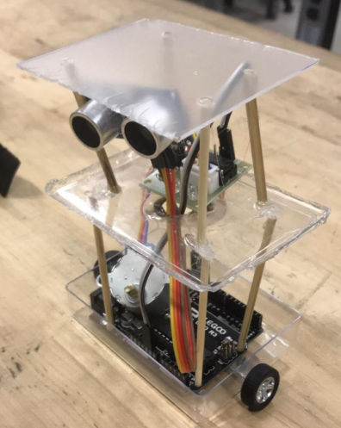

Figure 1: Final Prototype

This prototype has developed in the previous semester and now we are moving towards the manufacturing of device using the real products.

**Hardware Review**

First of all, we have purchased the Arduino UNO board as a main controller from which all the components will attach and control. Our purchased UNO controller has shown below

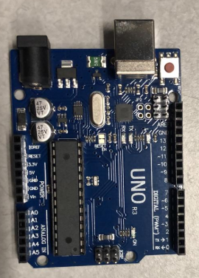

Figure 2: Arduino UNO

Above Arduino UNO board will install first on the robot structure and each component will connect with it through the jumper wire and it will send the instructions and signals to all the components. It will power up through the batteries and the code will load on it with the given instructions. For moving the robot, we have to use the wheels and wheels will rotate through the motors so as two wheels will use in it so two motors have bought to provide the rotation to the wheels.

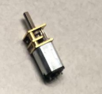

Figure 3: Motor

Above motor will use through the motor driver and that motor driver will connect with the Arduino UNO to get the instructions. These are DC motors and together two motors can easily drive the complete robot. The next thing we have purchased is gyroscope which has shown in the figure.

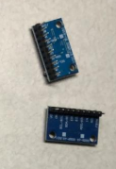

Figure 4: Gyroscope

We will use two gyroscopes, one for the front side and second for the backside to balance the robot. Gyroscope will use the gravity effect to see which side is not balance and then tilt the robot to opposite side to balance the robot. In this way the robot will stabilize easily and will not fall down on the rough terrains. Next thing we have purchased is battery which has shown in the following figure.

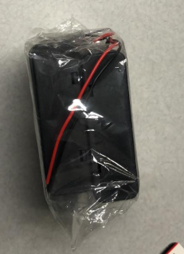

Figure 5: Battery

The battery will use to power up the complete robot and it will charge through the charger. In order to provide a long battery backup so that robot will not stop for long time we have purchased 4 batteries and these 4 batteries will connect together to provide high power backup for long time duration. And the batteries will tie with the battery holder which we have order but not arrived yet. These holders will tightly grip the batteries so the batteries will not move or make any imbalance while the robot is in motion. There are few things that need to buy for the robot

1. Two Wheels
2. Robot Structure
3. Ultrasonic sensors

The component will assemble after the testing has done and then it will install in the robot structure according to the design model and prototype. The complete product will test after the implementation.

**Conclusion**

In this memo a hardware review has presented for the project balancing robot, and the components purchased for the hardware has been reviewed in this memo. These components will assemble after the robot structure will make. Some components are still short but will purchased soon. The robot will test with all its functionality after all the components will assemble then detailed review will provide for the project.